**Requirement:**

If the project facilitates interactions with or between users or contributors there must be a mechanism for users and contributors to protect themselves against grief, abuse, and harassment. The project must have a mechanism to address the safety and security of underage users.

**Approach taken for development of Aajeevika:**

The application has provisioned the pre-defined values as dropdown options or radio buttons at most of the places in order to minimize text entry for the buyers and sellers on the marketplace. Production addition screen is given for reference.

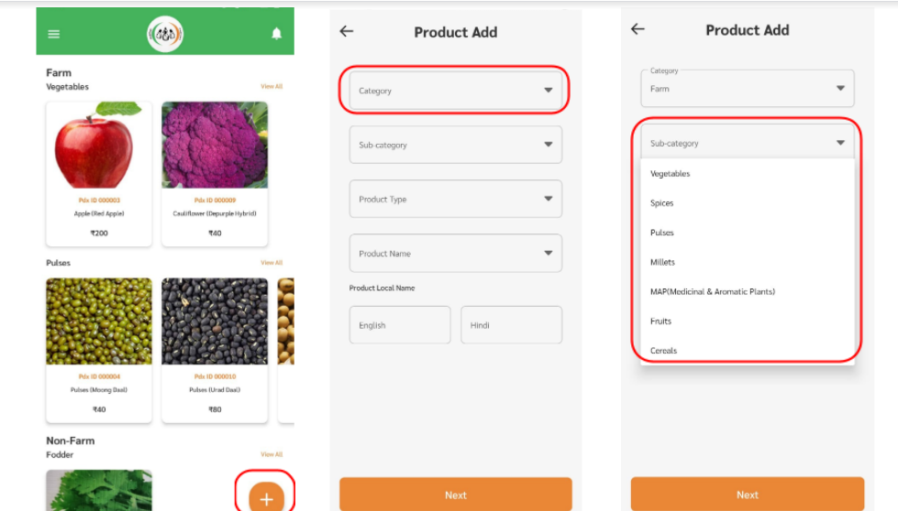

There is an in-built grievance redressal mechanism where the users can raise a grievance request which opens a ticket in the admin panel.

